OOP LAB 2 ASSIGNMENT

Q1.

#include <iostream>

using namespace std;

float residentialbill(){

int code,premiumchan;

float total;

cout<<"Enter the customers code:\t";

cin>>code;

cout<<"Enter the number of premium channels:\t";

cin>>premiumchan;

cout<<endl;

cout<<endl<<endl;

float billprocessfee=4.50;

float basicservicefee=20.50;

float premiumfee=premiumchan\*7.50;

total=billprocessfee+basicservicefee+premiumfee;

return total;

}

float businessbill(){

int accno,code,premiumchan,total,connections;

int rem;

cout<<"Enter the customers code: ";

cin>>code;

cout<<"Enter the number of premium channels: ";

cin>>premiumchan;

cout<<"Enter the number of connections: ";

cin>>connections;

cout<<endl;

float billprocessfee= 15.00;

float basicservicefee;

float premiumfee=premiumchan\*50.00;

if(connections<=10){

basicservicefee=75.00;

}

else

{

rem=connections-10;

basicservicefee= 75.00+ 5\*rem;

}

total= billprocessfee+basicservicefee+premiumfee;

return total;

}

int main(){

int accno;

char choice;

float x,y;

cout<<"1-Enter R or r For Residential Customers"<<endl;

cout<<"2-Enter B or b Business Customers"<<endl<<endl;

cout<<"Enter your choice: ";

cin>>choice;

switch(choice){

case 'r':

case 'R':

cout<<"Enter the customers account number: ";

cin>>accno;

x=residentialbill();

cout<<"The customer account no is: "<<accno<<endl;

cout<<"Total Billing Price of Residential customer is: $"<<x;

break;

case 'b':

case 'B':

cout<<"Enter the customers account number: ";

cin>>accno;

y= businessbill();

cout<<"The customer account no is: "<<accno<<endl;

cout<<"Total Billing Price of Business customer is: $"<<y;

break;

default:

cout<<"WRONG INPUT DETECTED"<<endl;

}

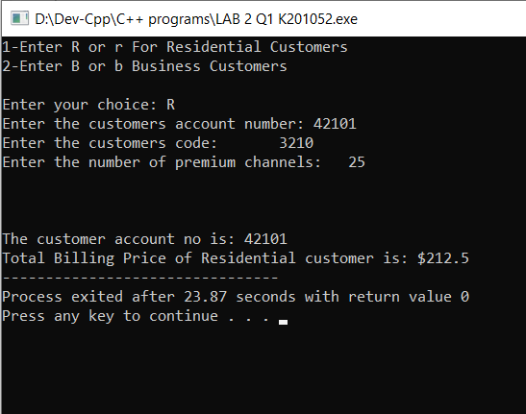}

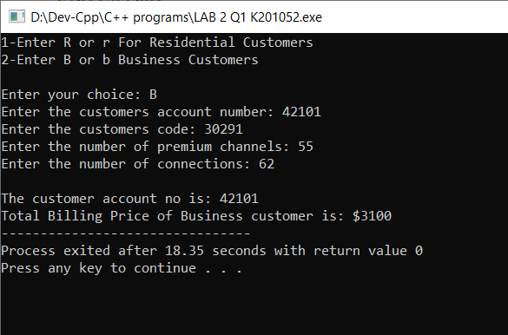

Q2.

#include <iostream>

using namespace std;

int showChoices();

void feetAndInchesToMetersAndCent(float feet, float inches);

void metersAndCentTofeetAndInches(float meters, float centi);

int main(){

int x;

float feet,inches,meters,centi;

x=showChoices();

switch(x){

case 1:

cout<<"Enter the length in feet: ";

cin>>feet;

cout<<"Enter the lengthin inches: ";

cin>>inches;

cout<<endl;

feetAndInchesToMetersAndCent(feet,inches);

break;

case 2:

cout<<"Enter the length in meter: ";

cin>>meters;

cout<<"Enter the lengthin centimeter: ";

cin>>centi;

cout<<endl;

metersAndCentTofeetAndInches(meters, centi);

break;

case 3:

cout<<"Program terminated\n";

break;

default:

cout<<"Enter the correct option\n";

main();

break;

}

}

int showChoices(){

int chooi;

cout<<"Enter 1 for converting feet and inches to meters and centimeter\nEnter 2 for converting meters and centimeter to feet and inches\nEnter 3 for exit\n";

cin>>chooi;

return chooi;

}

void feetAndInchesToMetersAndCent(float feet, float inches){

float ff,ii;

ff=feet\*0.3048;

ii=inches\*2.54;

cout<<feet<<" feet in meters is: "<<ff<<endl;

cout<<inches<<" inches in centimeter is: "<<ii<<endl;

cout<<endl;

main();

}

void metersAndCentTofeetAndInches(float meters, float centi){

float mm,cm;

mm=meters\*3.28084;

cm=centi\*0.393701;

cout<<meters<<" meters in feet is: "<<mm<<endl;

cout<<centi<<" centimeters in inches is: "<<cm<<endl;

cout<<endl;

main();

}

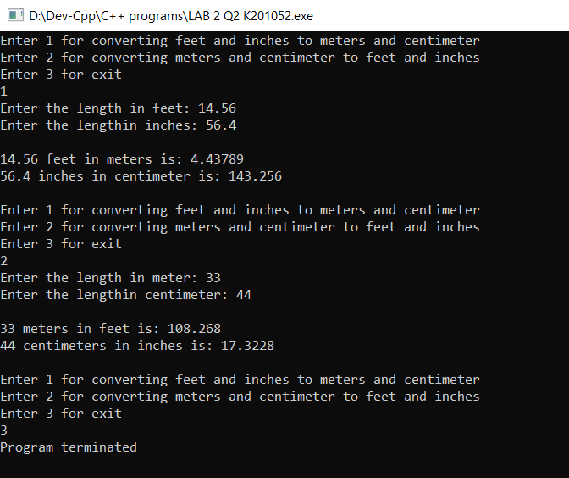

Q3.

#include <iostream>

#include <iomanip>

using namespace std;

double regularservice(int accno);

double premiumservice(int accno);

const float RCF = 10.00;

const float RR = 0.20;

const float PAF = 25.00;

const float PDR = 0.10;

const float PNR = 0.05;

int main(){

int accno;

char choice;

cout<<"This program calculates the bill for the cellular company\n\n";

cout<<"Enter the account no: ";

cin>>accno;

cout<<"Enter the type of service\n-(R or r) denotes regular bus service\n-(P or p) denotes premium bus service\n";

cin>>choice;

switch(choice){

case 'r':

case 'R':

cout<<"The due amount is: $ "<<regularservice(accno);

break;

case 'p':

case 'P':

cout<<"The due amount is: $ "<<premiumservice(accno);

break;

default:

cout<<"Enter the relevent service type code\n";

}

}

double regularservice(int accno){

float minutes;

double amount;

cout<<"Enter the no of minutes used by the customer: ";

cin>>minutes;

if(minutes > 50){

amount=((minutes-50)\*RR)+RCF;

}

else{

amount=RCF;

}

cout<<"Account no: "<<accno<<endl;

cout<<"Type of service: REGULAR"<<endl;

cout<<"Minutes used: "<<minutes<<endl;

return amount;

}

double premiumservice(int accno){

float dm,nm;

double amount;

cout<<"Enter the no of minutues used in day: ";

cin>>dm;

cout<<"Enter the no of minutes used in night: ";

cin>>nm;

if(dm > 75){

amount=((dm-75)\*PDR);

}

if(nm > 100){

amount=((nm-100)\*PNR);

}

amount= amount + PAF;

cout<<"Account no: "<<accno<<endl;

cout<<"Type of service: PREMIUM"<<endl;

cout<<"Minutes used: "<<dm+nm<<endl;

return amount;

}

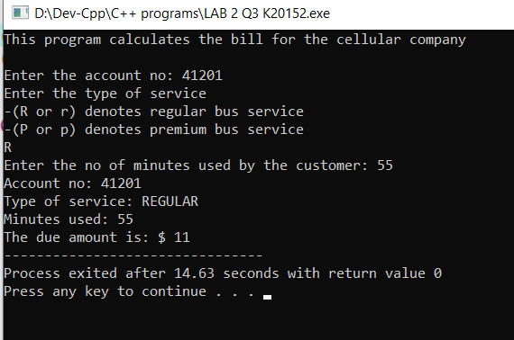

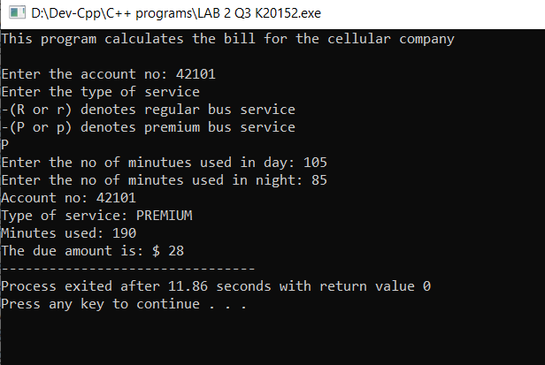

Q4.

#include<iostream>

#include<cmath>

using namespace std;

float distance(float x1,float y1,float x2,float y2);

float radius(float x1,float y1,float x2,float y2);

float circumference(float x1,float y1,float x2,float y2);

float area(float x1,float y1,float x2,float y2);

int main(){

float x1,y1,x2,y2;

cout<<"This program will give the\n1-Distance btw the points of circle\n2-The cicle's radius\n3-The cicle's circumference\n4-The cicle's area\n\n";

cout<<"Enter the centre of circle\n";

cout<<"Enter the x1 and y1 respectively: ";

cin>>x1>>y1;

cout<<"Enter the x2 and y2 respectively: ";

cin>>x2>>y2;

cout<<endl;

cout<<"The distance btw the points are: "<<distance(x1,y1,x2,y2)<<endl<<endl;

cout<<"The radius is equal to distance which is: "<<radius(x1,y1,x2,y2)<<" since a point is centre"<<endl<<endl;

cout<<"The circumference of the circle is: "<<circumference(x1,y1,x2,y2)<<endl<<endl;

cout<<"The area of the circle is: "<<area(x1,y1,x2,y2)<<endl<<endl;

}

float distance(float x1,float y1,float x2,float y2){

float u;

u=sqrt(pow(x2-x1,2)+pow(y2-y1,2));

return u;

}

float radius(float x1,float y1,float x2,float y2){

float u1;

u1=distance(x1,y1,x2,y2);

return u1;

}

float circumference(float x1,float y1,float x2,float y2){

float u2,u3;

u2=distance(x1,y1,x2,y2);

u3=2\*3.142\*u2;

return u3;

}

float area(float x1,float y1,float x2,float y2){

float u2,u3;

u2=distance(x1,y1,x2,y2);

u3=3.142\*pow(u2,2);

return u3;

}

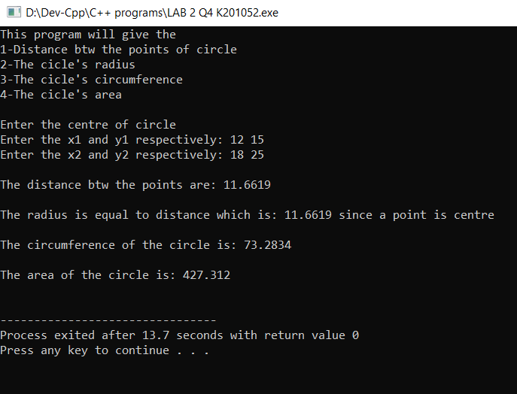

Q5.

#include<iostream>

#include<cmath>

using namespace std;

double billinamount(int hpr,int tct,int ti);

int main(){

double hpr;

int ti;

int tct;

cout<<"\*\*\*Welcome to J&J accounting, we provide firm assistance\*\*\*\n\n";

cout<<"Enter the hourly pay rate: ";

cin>>hpr;

cout<<"Enter the total consulting time in minutes: ";

cin>>tct;

cout<<"Enter the total income: ";

cin>>ti;

if(ti <= 25000 ){

cout<<"The customer has low total income\n";

}

else{

cout<<"The customer has high total income\n";

}

cout<<"The billing amount is: $ "<<billinamount(hpr,tct,ti);

}

double billinamount(int hpr,int tct,int ti){

if (ti <= 25000) {

if (tct <=30)

return 0;

else

return hpr\*0.40\*((tct-30)/60);

}

else {

if (tct <= 20)

return 0;

else

return hpr\*0.70\*((tct-20)/60);

}

}

